Mendel University in Brno

In cooperation with the HORIZON 2020 SPOT project[1]

*7th Moravian on-line Conference*

*on Rural Research*

SMART COUNTRYSIDE

for the 21st CENTURY

September 1-4, 2020



2nd circular, Spring 2020

Brno, Mendel University

*Dear colleagues,*

Rural areas were traditionally connected with agriculture. To compare with urban, rural areas were considered to be backward, retarded, not worthy of intensive research. But the situation has changed during the last decennials. Although cities are still centres of development within the globalization process, many people in Europe abandon them as a result of the trends of suburbanization and counter-urbanization. We intend to pay our attention to transformation processes of the European countryside where focusing on more processes occurring there as a transformation from productive to non-productive function, from centrally planned to the market-oriented countryside, from the mono-functional to the multifunctional one, from the national to European and globalized place. The urbanization process shows more faces in the European countryside. Such a transformation generates many impacts on natural, economic and social processes occurring in the present European countryside.

Cities make their efforts to be smart. Has the European countryside also any potential to be smart? Does smart countryside mean the same as a smart city? The Bled conference between the European Commission and European Parliament from August 2018, which was dedicated to smart villages, has opened a set of questions and challenges in this sense.

We have the honour of inviting you to the EURORURAL '20 conference on SMART COUNTRYSIDE FOR 21ST CENTURY. It is the 7th of Moravian rural conferences organised by the Department of Applied and Landscape Ecology, Faculty of AgriSciences, Mendel University in Brno. The aims of the conference are as follows: to map European rural research and particular interests of investigators, to gain space for the presentation of contemporary knowledge about rural research, to continue in the tradition of international conferences dedicated to rural problems, to support intra-personal contacts among experts of different disciplines dealing with rural problems, to present South Moravian rural landscape. The conference is aimed at a relatively complex view of rural problems from different viewpoints (ecology, geography, demography, sociology, economy, territorial planning), less at the research of specific problems in detail.

The conference is open for all scientists, including PhD students, dealing with rural matters from universities, research institutions or other public or private bodies from European countries and around the World. The conference will be held on-line, physical participation is not expected.

**CONFERENCE TOPICS SMART VILLAGES**

The content of the Conference will be directed mainly (not exclusively) to the following topics:

* + - * Teleworking and a question whether it is possible to substitute face-to-face contacts by on-line activities and thus to operate a highly qualified work from rural homes
* Coverage of the rural space with a speed internet, cell phone signal and other communication media and utilization of these media in the rural life and entrepreneurship
* Intelligent systems of technical infrastructure (transport, energy supply, water management etc.)
* Using smart systems for the development of rural forms of tourism
* Online purchase and on-line services in the rural space - an alternative way of the coverage of the population demands
* Any other smart system enabling to connect the rural way of life with an urban level of services and jobs

**ADDITIONAL CONFERENCE TOPICS**

* Common Agricultural Policy 2020-2025 and its impact on sustainable European agriculture
* Community Lead Local Development and its impact on rural development
* Cultural tourism and it's potential for the post-productive European countryside
* Any other topical problem concerning contemporary European countryside

**SPECIAL SESSION**

A special section will be devoted to the consequences of the COVID 19 epidemic for the European countryside. In this context, several questions arise, such as:

* Is a city or countryside more sensitive to such events?
* How will the restriction of population movement on seasonal agricultural work be reflected?
* How will the restriction of population movement on rural tourism be reflected, will domestic tourism grow at the expense of foreign ones?
* The relationship between companies and people, especially rural seniors, to work from home will change?
* Will the epidemic experience become a major impetus for the further development of online services that could partially offset the disappearing social infrastructure of rural settlements?
* Smart technologies in the fight with Covid-19 (monitoring the spread of disease through ICT)
* eventually other

Obviously, at the time of the conference, there will not be enough empirical data for processing scientific papers. Therefore, this section will focus more on the contributions of the character research note (theoretical discussion) or short communication (partial empirical knowledge). The idea is to create a potential for a special issue of European Countryside journal or one or more joint articles.

**VENUE**

**Mendel University is the third largest and the fourth oldest university in Brno. It was established in 1919 as the Agricultural College. At present, 9,200 of Czech and about 600 foreign students study at one of five faculties: AgriSciences, Forestry and Wood Technology, Horticulture (situated in Lednice, South Moravia), Business and Administration, Regional Development and International Studies and at the Institute of Lifelong Learning. The University uses the University Training Farm at Žabčice and the Forest Training Enterprise "Masaryk Forest" at Křtiny. Student accommodation facilities provide 3,148 beds. The library disposes of with more than 400,000 issues, being the 3rd largest library in the City.**

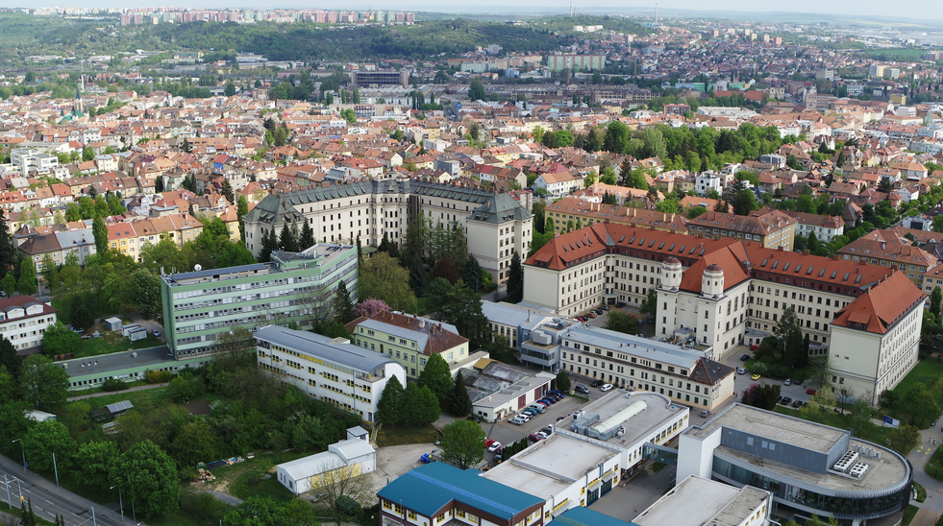

**FORMAT OF THE CONFERENCE**

Given the current epidemiological situation in Europe, an online conference will take place. Contributions of individual participants will be posted on a special website during the conference. At this time, the website will be accessible to conference participants and open for discussion. At the end of the discussion, the papers (possibly adjusted based on the discussion results) will be open to the general public with the consent of the authors.

The *Book of Long Abstracts* will be published. The presentation of contributions on the web page is not preconditioned with submitting a long abstract. The authors will be able to publish their contributions in the *European Countryside* journal with a significant discount.

If the situation allows, a physical conference in limited format can be held in parallel to discuss selected issues in the term of September 1-3, 2020. In this case, the participants will be addressed as soon as the conditions allow.

*Mendel University in Brno. The main campus*

**CALL FOR PAPERS**

Long abstracts both papers and posters will be published. The deadline for submitting of long abstracts of key performances, papers and posters are **July 31, 2020**. The length of the abstract should not exceed 2 pages (4,000 characters, including spaces). The text should be sent by electronic mail in MS Word. The authors are responsible for content and language. The Collection of the Abstracts will be published and sent to the participants.

To offer you the publication of your presentation in an international journal, your full papers will be submitted to *European Countryside* - if you wish it - for a limited price of EUR 120 (payable after the acceptance of the paper). It is also possible to pay for the publication within the conference fee (in such a case for EUR 95 per paper). *European Countryside* is an

European Countryside [http://www.degruyter.com/view/j/euco] is an international on-line journal with completely free access for its readers. The journal is covered by many databases, including ESCI Clarivate Analytics and Elsevier SCOPUS. This fact creates a relatively high probability of quotations of the articles. Your papers can be delivered any time between payments of your conference fee and August 2021. The papers must follow the instructions for authors of the European Countryside [http://www.european-countryside.eu/submit.html]. They will pass through a standard double-blinded peer-review procedure which is the pre-condition of their publication.

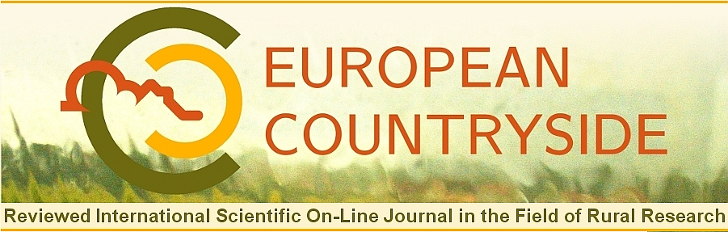

**SCHEDULE**

Early payment May 15, 2020

Submission of long abstracts July 3, 2020

Submission of the conference contributions August 15, 2020

Accessibility of the conference contributions with the possibility to discuss them

September 1 – 30, 2020

Deadline for eventual revision of materials October 30, 2020

Making the contributions available for a wide public November 16, 2020

Deadline of the submission of contributions to the European Countryside journal

August 31, 2021

**REGISTRATION FEE**

Registration fee early payment before May 15, 2020 CZK 500

Registration fee late payment after May 15, 2020 CZK 750

Registration fee PhD. student CZK 400

Publication in European Countryside CZK 2 500

The basic registration fee includes conference materials, organizational costs, the printing of the Book of Abstracts, VAT 21 %.

**Way of payment:** Bank transfer: Account number 7200310267/0100, variable 2200101. Account owner: Mendel University in Brno. All bank fees are a matter of the debit balance of the participants. Bank: Komerční banka, Brno - Černá Pole, Merhautova 1, 631 32 Brno; SWIFT (BIC): KOMBCZPPXXX, IBAN: CZ7001000000007200310267.

The exchange rate is 1 EUR for 27.595 CZK in April 2020.

The simplified tax certificate will be made after the payment.

**Contacts:** Assoc. prof. Antonín Vaishar, CSc.

**Web page:** <http://www.eurorural.eu/>

**e-mail:** [eurorural20@seznam.cz](mailto:eurorural20@seznam.cz)



1. This project has received funding from the European Union’s Horizon 2020 programme for research and innovation under grant agreement [no. 870644](https://cordis.europa.eu/project/id/870644)